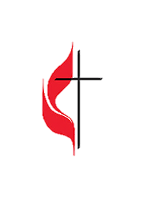 **\*The order of service is** subject to change at theleading of **the Holy Spirit.**

***Bold print*** invites congregational response in unison.

*Means you are **invited to stand** if able and comfortable.

Large print hymnals, large print bulletins, service script, pew cushions, and Listening Assistance Devices are available at the entry of the Sanctuary.

**You’re encouraged to check-in** at NMUMC on Facebook & share recorded service.

**We Gather together**

**Light the Candle** Ariana O’Rourke

**Welcome** Pastor Lee

**Welcoming Statement** Together

**Announcements** Pat Tripp

**\*Praise and Worship**

“I’ll Fly Away” TFWS # 2282

“Shout To The Lord” TFWS # 2027

“Come, Now Is The Time To Worship” WS # 3176

**Words to Ponder** Pat Tripp

Christ is the light of God’s glory and the imprint of God’s glory. Let all God’s children come to the light.

**Call to Worship** Pat Tripp

Walk humbly before the Lord, even in hardship and pain.

**We will live with integrity before God all the days of our lives.**

Walk faithfully before our God, even when put to the test.

**We will honor the Lord our God all the days of our lives.**

Come! Let us worship**.**

**Opening Prayer** Together

**Almighty God, you spoke to our ancestors long ago through your prophets and teachers, but today you speak to us through your Son. In the midst of life’s trials and tribulations, help us keep our integrity and walk faithfully in your ways. Help us listen to the words of your Son and become like children again, that we may rejoice in your kingdom and trust in your Spirit. Amen.**

**Lord’s Prayer** Together

**Our Father who art in heaven, hallowed be thy name. Thy kingdom come. Thy will be done  
on earth as it is in heaven. Give us this day our daily bread, and forgive us our trespasses,  
as we forgive those who trespass against us, and lead us not into temptation, but deliver us from evil. For thine is the kingdom and the power, and the glory, forever and ever. Amen.**

**\*Hymn of Praise** “May Gifts One Spirit” UMH # 114

**\*Passing of the Peace of Christ** Pat Tripp

**Children’s Sermon** Terri Hudak

**We Hear the Word**

**Words of Illumination** Pat Tripp

Rejoice, for we are sanctified by God and Jesus calls us brothers and sisters. As Christ’s sisters and brothers, rest secure in the assurance of God’s saving love. Amen.

**\*Scripture Reading Mark 9:38-50** Pat Tripp

**38**“Teacher,” said John, “we saw someone driving out demons in your name and we told him to stop, because he was not one of us.” **39**“Do not stop him,” Jesus said. “For no one who does a miracle in my name can in the next moment say anything bad about me, **40**for whoever is not against us is for us. **41**Truly I tell you, anyone who gives you a cup of water in my name because you belong to the Messiah will certainly not lose their reward. 42“If anyone causes one of these little ones—those who believe in me—to stumble, it would be better for them if a large millstone were hung around their neck and they were thrown into the sea. 43 If your hand causes you to stumble, cut it off. It is better for you to enter life maimed than with two hands to go into hell, where the fire never goes out.  45And if your foot causes you to stumble, cut it off. It is better for you to enter life crippled than to have two feet and be thrown into hell.  47 And if your eye causes you to stumble, pluck it out. It is better for you to enter the kingdom of God with one eye than to have two eyes and be thrown into hell, 48 where” ‘the worms that eat them do not die, and the fire is not quenched.’**49** Everyone will be salted with fire. **50**“Salt is good, but if it loses its saltiness, how can you make it salty again? Have salt among yourselves, and be at peace with each other.”

Reader: This is the word of God for the people of God.

**People: Thanks be to God.**

**Reflecting on God’s Message** “Whoever Is NOT Against Us”Pastor Lee

**Prayers of the People** Pastor Lee

**We Respond to the Word**

**Invitation of the Offering** Pastor Lee

One way that we become a flavorful and peaceful community is by sharing the gifts of our lives with the world. We are a compassionate and generous people, so let us give joyfully.

**Offertory Anthem** “Cares Chorus ” Hand Bell Choir

by: Kelly Willard; arr. by: Peggy Bettcher

**\*Doxology** UMH #95

**“Praise God, from Whom All Blessings Flow”**

**Praise God, from Whom all blessing flow;**

**Praise Him, all creatures here below;**

**Praise Him above, Ye heavenly Host;**

**Praise Father, Son, and Holy Ghost. Amen**

**\*Offering Prayer** Together

**God of love, just as you speak to us through a Son, speak to your world through our gifts. May our offering receive your blessing and go forth to bring life and love to a world in need of both. Amen.**

**We Reach Out to the World**

**\*Sending Hymn** “They’ll now We Are Christians By Our Love”TFWS #2223

**\*Benediction** Together

As you have refreshed us at your table,

**Weave us together as one body, one people – a people of integrity in the midst of trials.**

As you have shared your sacred meal with us,

**Strengthen us, that we may be united in faith – a faith that spans the globe and the ages.**

As you have blessed us with your loving presence,

**Send us forth in courage and peace, rejoicing in the power of your Spirit. Amen.**

**Postlude** Harlan Otter

**Event Announcements:**

* **Haunted Trail:** Saturday October 12, Friday October 18, Saturday October 19, Friday October 26, and Saturday October 27
  + Volunteers are needed for the following dates. Contact Steve Kolitz with any questions or to sign up.
    - 10/12 Saturday need 5 more
    - 10/18 Friday need 6 more
    - 10/19 Saturday need 4 more
    - 10/25 Friday need 3 more
    - 10/26 Saturday need 8 more

**Nineteenth Sunday After Pentecost**

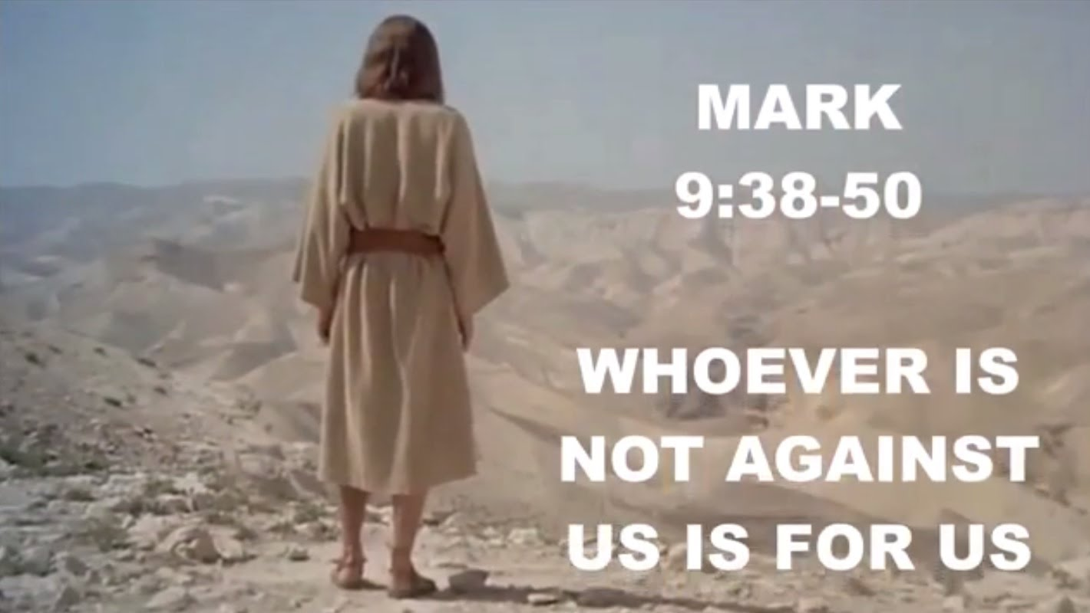

*dioceseofmanzini.org*

**9.29.2024 | 9:30 am**

***You are invited to worship with us in the quiet of prayer, in the joy of song,***

**and in the desire to grow in the graceand knowledge of our LORD Jesus Christ.**

**Part of our mission is to be a place for all people. All are welcome here!**

**Whatever your gender identity, age, race, religious background, economic status,**

**sexual orientation or condition of ableness, we greet you as a beloved child of God.**

**Pastor Yongyeun Lee 203-969-5461; Email: yongyeunlee@gmail.com**

Music Director, Harlan Otter | Liturgical Arts, Barbara Williams |Liturgist –Pat Tripp

Children’s Participation: Acolyte: Ariana O’Rourke; Bell Ringer: Bella O’Rourke

Ministers: *All members of the New Milford UMC*

Pastor’s Office Hours: 9:00AM – 12:00PM, Tuesday through Friday

68 Danbury Road, New Milford, CT 06776 | www.newmilfordumc.org | 860.354.4596