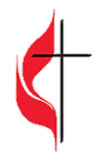
*The order of service is subject to change at the leading of the Holy Spirit.
Bold print invites congregational response in unison.
*Means you are invited to stand if able and comfortable.
Large print hymnals, large print bulletins, service script, pew cushions, and Listening Assistance Devices are available at the entry of the Sanctuary.
You are encouraged to check-in at NMUMC on Facebook & share recorded service.
We Gather together
Prelude Harlan Otter
Welcome Pastor Lee
Welcoming Statement Together
Announcements Pastor Lee
*Praise & Worship “This is the Day” UMH # 657
“There is None Like You” Screen
Words to Ponder Kay Jones
Come into God’s presence and relinquish all fear. Let go of life as you know it and discover life everlasting.
Call to Worship Kay Jones
Incline your ear, O God. Hear the praises of your people.
Gladden the hearts of your servants, as we lift up our souls to you.
For you, O God, are good and forgiving, abounding in steadfast love.
In the day of trouble we call on you, knowing you will answer.
Your people everywhere glorify your name. .
For you are slow to anger, and abound in steadfast love.
Turn to us and be gracious.
Opening Prayer (in unison) Together
Thank you, Loving Spirit, for the warmth of summer and for your invitation to embrace abundant life. Your promise of resurrection allow past troubles to die, as we rise with you to new life. Inspire us to follow your lead, even when it requires us to bear a cross of sacrifice in your name. May our love for you be complete, as we share words and acts of compassion with a world that years for peace. Amen.
Lord’s Prayer Together
Our Father who art in heaven, hallowed be thy name. Thy kingdom come. Thy will be done on earth as it is in heaven. Give us this day our daily bread, and forgive us our trespasses, as we forgive those who trespass against us, and lead us not into temptation, but deliver us from evil. For thine is the kingdom and the power, and the glory, forever and ever. Amen
*Hymn ”This is the Father’s World” UMH # 144
Passing of the Peace of Christ Pastor Lee
Children’s Message Terri Hudak
We Share the Gifts
Invitation to the Offering Pastor Lee
Your offering today becomes compassion made visible: a meal shared, a prayer answered, a ministry strengthened, a neighbor reminded they are not alone. Let us give with gratitude, trusting that God multiplies every gift offered in love.
Offertory Anthem Patty Jacobson
*Doxology UMH #95
*Offering Prayer (in unison) Together
Loving God, what shall we return to you for your great bounty in our lives? Your generosity knows no limits. Your loving compassion pours into our hearts and our very beings. We thank you. We call upon you, trusting our love. We offer you all that we have and al that we are, hoping for your glory and desiring your kingdom. Amen.
We Hear the Word
Words of Illumination Kay Jones
Open us now to the wisdom of Your Word. Let familiar stories shimmer with new grace, and let quiet truths rise to the surface like seeds ready to grow. Amen
*Gospel Reading: Mathew 10:24-39 Pastor Lee
²⁴ “A disciple is not above the teacher nor a slave above the master; ²⁵ it is enough for the disciple to be like the teacher and the slave like the master. If they have called the master of the house Beelzebul, how much more will they malign those of his household! ⁶ “So have no fear of them, for nothing is covered up that will not be uncovered and nothing secret that will not become known. ²⁷ What I say to you in the dark, tell in the light, and what you hear whispered, proclaim from the housetops. ²⁸ Do not fear those who kill the body but cannot kill the soul; rather, fear the one who can destroy both soul and body in hell. ²⁹ Are not two sparrows sold for a penny? Yet not one of them will fall to the ground apart from your Father. ³⁰ And even the hairs of your head are all counted. ³¹ So do not be afraid; you are of more value than many sparrows. ³² “Everyone, therefore, who acknowledges me before others, I also will acknowledge before my Father in heaven, ³³ but whoever denies me before others, I also will deny before my Father in heaven. ³⁴ “Do not think that I have come to bring peace to the earth; I have not come to bring peace but a sword. ³⁵ For I have come to set a man against his father, and a daughter against her mother, and a daughter-in-law against her mother-in-law, ³⁶ and one’s foes will be members of one’s own household. ³⁷ “Whoever loves father or mother more than me is not worthy of me, and whoever loves son or daughter more than me is not worthy of me, ³⁸ and whoever does not take up the cross and follow me is not worthy of me. ³⁹ Those who find their life will lose it, and those who lose their life for my sake will find it.
Reader: This is the word of God for the people of God.
People: Thanks be to God.
Reflecting On God’s Message “Father’s Love” Pastor Lee

Prayers of the People Pastor Lee
We Reach Out to the World
Sending Hymn “Take Up Thy Cross” UMH # 415
*Benediction Together
We believe in a God of new beginnings!
May the grace of Christ, the love of God and the communion of the Holy Spirit bring hope to our hearts and peace to God’s world. Amen
Postlude Harlan Otter
Event Announcements:
- Happy Father’s Day! With deep gratitude, we honor all fathers, father figures, uncles, mentors, and steady guides whose sacrifice, love, and wisdom help shape us into who we are.
- Recognition Sunday: Today
- Fraud Prevention Seminar: Tuesday June 23 6:00 – 7:30pm in FH. Contact the office to RSVP; contact Steve Kolitz with any questions.
- Healing Service: Sunday June 28, 9:30am; Testimonies by: Carolyn Dion, Harold Jacobson, and Terri Hudak
- Chapel in the Pines: begins Sunday July 5 at 9:00am
  - If you have any favorite hymns or contemporary songs for the Chapel in the Pines, please write the hymn number or the title of the song and put them in the offering place
- Prayer Center: The sanctuary is open every Wednesday 12:00 Noon to 1:00pm; a quiet hour set apart to pray for world peace.
Fourth Sunday After Pentecost
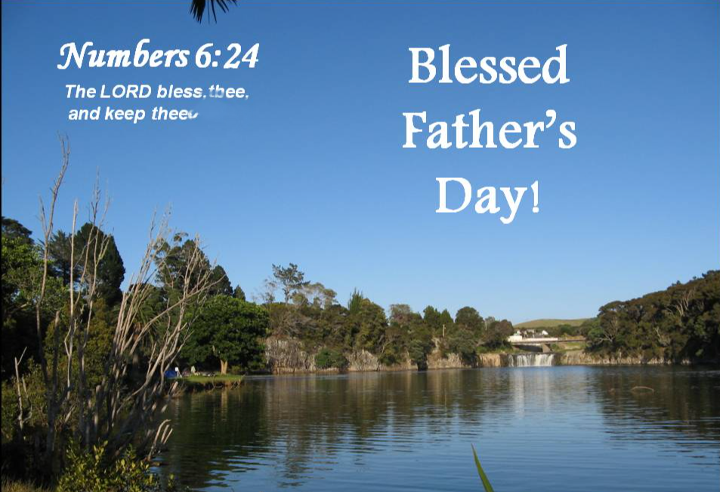
clipart-library.com
06.21.26 | 9:30am
You are invited to worship with us in the quiet of prayer, in the joy of song,
and in the desire to grow in the grace and knowledge of our LORD Jesus Christ.
Part of our mission is to be a place for all people. All are welcome here!
Whatever your gender identity, age, race, religious background, economic status,
sexual orientation or condition of ableness, we greet you as a beloved child of God.
Pastor Yongyeun Lee 203-969-5461; Email: yongyeunlee@gmail.com
Music Director, Harlan Otter | Liturgical Arts, Barbara Williams |Liturgist – Pastor Lee
Children’s Participation: Acolyte and Bell Ringer
Ministers: All members of the New Milford UMC
Pastor’s Office Hours: 9:00AM – 12:00PM, Tuesday through Friday
68 Danbury Road, New Milford, CT 06776 | www.newmilfordumc.org | 860.354.4596

